**air quality monitoring**

**PHASE 4: Development Part 2**

**AIR QUALITY MONITORING – IOT**

***Phase 3: Development Part 2***

**Introduction:**

As our cities and industries grow, monitoring and understanding air quality have become crucial for public health, environmental conservation, and sustainable urban development. With advancements in the Internet of Things (IoT), real-time data collection from distributed sensors has become more accessible than ever. This project aims to harness the power of IoT and web technologies to create a platform that displays real-time air quality data. By collecting and visually representing this data, stakeholders from everyday citizens to policymakers can make informed decisions and strategies for cleaner, healthier living environments.

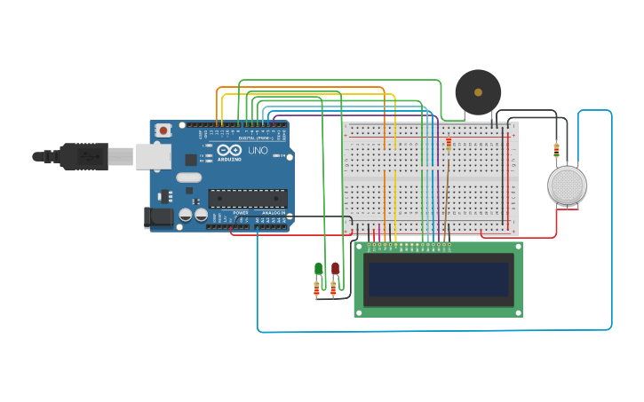

Transforming a design into a tangible solution involves a series of steps that ensure both functionality and scalability. Let's delve into the steps required to turn the air quality monitoring platform design into reality.

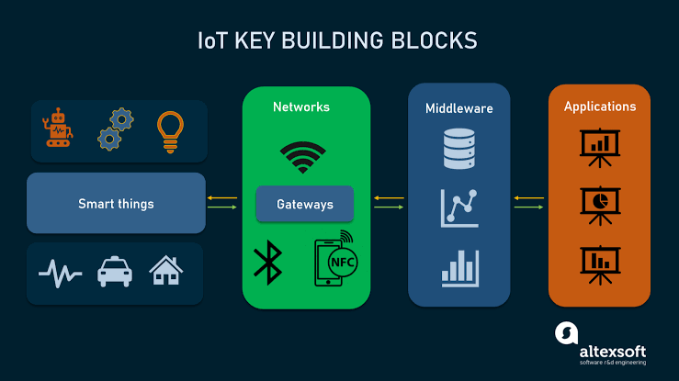

Step-by-Step Transformation of the Air Quality Monitoring Design:

1. Requirement Analysis:

- Understand and document the precise requirements of the system, such as the metrics to be tracked (PM2.5, PM10, temperature, humidity, etc.), frequency of data updates, and target audience (public, government, etc.).

2. Hardware Procurement:

- Acquire reliable IoT devices that can measure air quality metrics. Choose sensors that are accurate, have longevity, and can operate in varied environments.

3. Backend Development:

- Create a backend server using a technology like Node.js or Python (Flask/Django). This server will:

- Communicate with the IoT devices to receive real-time data.

- Store this data in a database, such as PostgreSQL, MySQL, or a time-series database like InfluxDB, optimized for time-stamped data.

- Offer an API for the frontend to fetch real-time and historical data.

4. Frontend Development:

- Refine the basic platform designed in the previous step. Make it responsive so it can adapt to various devices like mobiles, tablets, and desktops.

- Use frameworks/libraries like React or Vue.js to make the dashboard dynamic and real-time.

- Integrate data visualization tools or libraries like Chart.js or D3.js to display data trends over time.

5. Testing:

- Test the IoT sensors in various conditions to ensure accurate data collection.

- Conduct unit tests on backend and frontend components.

- Perform integration tests to ensure seamless interaction between frontend, backend, and IoT devices.

- Test the platform's performance under high loads to ensure scalability.

6. Deployment:

- Deploy the backend server on cloud platforms such as AWS, Azure, or Google Cloud.

- Set up a Continuous Integration/Continuous Deployment (CI/CD) pipeline to automate deployment processes.

- Use platforms like Netlify, Vercel, or traditional web hosts to deploy the frontend.

7. Monitoring and Maintenance:

- Monitor the health of IoT devices. Set up alerts for device failures or anomalies.

- Monitor the health of the backend server, ensuring uptime and performance.

- Periodically check for software updates, security patches, and other relevant enhancements.

8. Feedback Loop:

- Encourage users to provide feedback on the platform's usability and features.

- Use this feedback to make iterative improvements, ensuring the solution remains user-centric.

9. Expansion and Scalability:

- Based on usage trends and user feedback, plan for potential expansions. This might include adding more IoT devices in new locations or integrating more advanced analytics features.

- Ensure that the server and database can handle increased loads, which might require optimizations or migrating to more robust systems.

10. Public Awareness and Education:

- Create educational content that explains air quality metrics, their significance, and any health implications. This helps users interpret the data and understand its importance.

- Collaborate with local governments or environmental agencies to increase platform visibility and reach.

11. Continuous Innovation:

- Explore new technologies or methods that can enhance data accuracy or offer new insights.

- Integrate AI and Machine Learning models to predict air quality trends or detect anomalies.

- Look for partnership opportunities with environmental organizations, tech companies, or academic institutions to further enhance and refine the platform.

By following these steps meticulously, the design can be transformed into a comprehensive air quality monitoring solution, capable of delivering real-time insights while being adaptable to future enhancements and innovations

Building a platform to display real-time air quality data involves several components – the frontend (what users interact with), the backend (the server logic and database operations), and the connection to IoT devices.

**Here's a step-by-step guide:**

**1. Backend Development:**

**Technologies:** Node.js (Express.js framework) and MongoDB as a database.

Steps:

**a. Setup Express.js:**

Install required packages:

bash

npm init

npm install express mongoose body-parser

**b. Connect to MongoDB using Mongoose:**

javascript

const mongoose = require('mongoose');

mongoose.connect('mongodb://localhost:27017/airQualityDB', {useNewUrlParser: true, useUnifiedTopology: true});

**c. API Endpoint to receive data from IoT devices:**

javascript

app.post('/updateData', (req, res) => {

// Save the data to MongoDB

});

**2. Frontend Development:**

Technologies: HTML, CSS, JavaScript, and AJAX (to fetch real-time data).

**Steps:**

**a. Create HTML Structure (`index.html`):**

html

<!DOCTYPE html>

<html lang="en">

<head>

<meta charset="UTF-8">

<meta name="viewport" content="width=device-width, initial-scale=1.0">

<title>Air Quality Dashboard</title>

<link rel="stylesheet" href="styles.css">

</head>

<body>

<h1>Air Quality Data</h1>

<div id="data">

<!-- Data from the server will be populated here -->

</div>

<script src="script.js"></script>

</body>

</html>

**b. Style with CSS (`styles.css`):**

css

body {

font-family: Arial, sans-serif;

padding: 20px;

}

**c. Fetch and Display Data (`script.js`):**

javascript

function fetchData() {

fetch('/updateData')

.then(response => response.json())

.then(data => {

// Populate the data into the 'data' div

document.getElementById("data").innerHTML = `

PM2.5: ${data.pm25} <br>

PM10: ${data.pm10} <br>

Temperature: ${data.temperature}°C <br>

Humidity: ${data.humidity}%

`;

});

}

// Fetch data every 10 seconds

setInterval(fetchData, 10000);

**3. Connection to IoT Devices:**

Assuming the IoT devices can send HTTP POST requests, they'll send data to the `/updateData` endpoint. The backend (Express.js server) will process this data, save it to MongoDB, and then the frontend will fetch and display this data at regular intervals.

**4. Deployment:**

**Backend:**

- Use platforms like Heroku, DigitalOcean, or AWS to deploy the Node.js server.

**Frontend:**

- Host static files using services like Netlify, Vercel, or traditional web hosts.

**5. Secure Data Transfer:**

- Use HTTPS to ensure the data being sent from IoT devices to the server is encrypted.

- Authenticate IoT devices to prevent unauthorized data from entering the system.

Remember, this is a basic implementation. In a real-world scenario, you'll need to consider scalability, handle potential errors, secure the data, and regularly update the platform based on user feedback and technological advancements.

**Conclusion:**

The integration of IoT with web development technologies offers transformative potential for addressing contemporary environmental challenges. By building a platform that can seamlessly receive and display real-time air quality data from distributed IoT devices, we empower individuals and communities with timely insights into their surroundings. Such platforms not only promote awareness but also serve as a cornerstone for environmental initiatives, policymaking, and community actions. As we move forward in this digital age, leveraging these technologies will be essential in fostering sustainable urban environments and safeguarding public health.